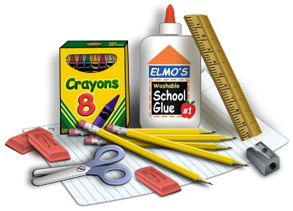

**Winterset Elementary**

**2024-2025 Supply List**

**Specialized Learning Center Classrooms**

**Kdg – 1st Grade 2nd -5th Grade**

6 large pencils 24 pencils Ticonderoga preferred

8 pack large diameter crayons 24 pack Crayola crayons

**All grades** **Kdg –5th Grade**

8 glue sticks

Scissors

Set of headphones for computer use

4 boxes Kleenex

3 SOLID colored 2 pocket folders (with nothing written on them)

2 packages of antibacterial wipes (such as Lysol, etc.)

A complete change of clothes to keep at school

Toileting supplies if your child needs toileting assist (diapers/pullups and wipes)